**Specifications for the control Architecture of the PL_ONE (Manual mode)**

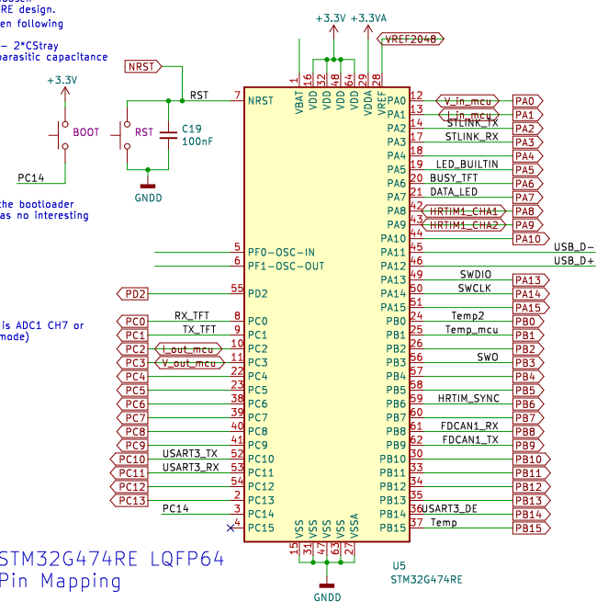

|  |  |  |  |  |  |
| --- | --- | --- | --- | --- | --- |
| Board Peripheral | MCU  Peripheral | pins | Type | Description |  |
| TFT |  |  |  |  |  |
|  |  |  |  |  |
|  |  |  |  |  |
| ADC |  |  |  |  |  |
|  |  |  |  |  |
|  |  |  |  |  |
|  |  |  |  |  |
| RS485 BUS |  |  |  |  |  |
|  |  |  |  |  |
|  |  |  |  |  |
|  |  |  |  |  |
| STLINK |  |  |  |  |  |
| CAN BUS |  |  |  |  |  |
|  |  |  |  |  |
|  |  |  |  |  |

**General informations about the system :**   
1 – Modules Boards are defined as master or slave in their code source and that feature can't be changed by the customer.

2 - The master board is the one wich is connected to the screen .

3 - all boards are connected to the CAN bus through RJ45 connection .

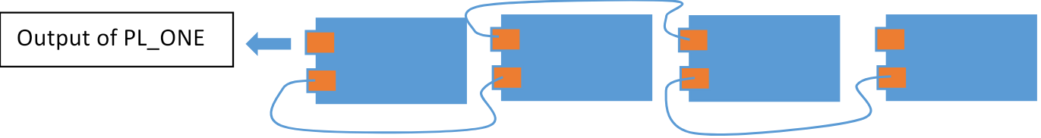

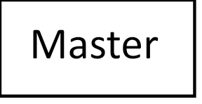



5-The General Converter Mode (GCM) and the IN_OUT references (voltage , current , etc…) can’t be change in real time . A startup is needed for all the boards to start together with the same regulation parameters. (from where these parameters provided? They must be a starting parameter embedded in the code.)

6- Battery in input need to be charged a little bit or PL_one can not start (how this information effect on the code?)

**Startup sequence**

1. A switch allow voltage to go to input of feeder
2. Fedeer **power supply active (UVLO treated with NCP700 and TI)**
3. **Initial Checkup sequence** (measure of board state :

Board state :

* Temperatures boards_init < 80deg
* Vin_init < 100V
* Vout_init < 100 V
* Iin_init < 25A
* Iout _init < 25A

(what is the relation between adc values and the real values? Adc values are below 3.3V)

Initial board status checkup (Bool Init_bd_st_ckp) return :

All ok (return 1)

If : ( TB < value , Vin < value , Vout < value , Iin < value , Iout < value)

Otherwise , Board status checkup return a fault (0) and the code execution can’t continue.

A continuous supervision of these parameters need to be done to be able to stop PWM generation in case of problem . (what is the frequency of checking the parameters?)

That feature will is implemented in the code source off all boards (Masters and slaves) and the Boards remount in real time their status through the CAN Bus in a boolean variable to the master.

In case of Fault the whole system stop.

That constant supervision will compare the parameters :

* Temperatures boards < 80deg
* Vin < 100V
* Vout < 100 V
* Iin= < 25A (on the top, Iin_init, there is no equal, shall it must be here? I mean =<)
* Iout < 25A

With some references.

3 - **Status Led**

The status LED is directly driven by a PWM signal from the PIN Data Led (PA7) of MCU.

That PWM signal determine the color of the LED

And the color of the LED is green in case of no fault on all board and red if there is a fault.

What is the frequency of red and green light? Also on which duty cycle?

4-**TFT Screen access**

Once the status LED pass to green the user can access the TFT screen. Accessing to the lcd is always possible or just at the start up the system?

Check the possibility to block access to the TFT screen with the busy TFT pin (PA6) of MCU. It is possible and already done.

On the TFT screen, the user can :

4-1- **User define the General System Mode in automatic or manual**

The automatic system mode is defined in another document

**Automatic mode brief description :**

The converter go get infos from the battery and from the inverter and use theses infos to decide of the regulation mode and of the regulation parameters. How these infos are given to the system? By lcd or other ways?

**Manual mode brief description :**

The user enter the infos for the regulation mode and of the regulation parameters.

4-2- **User activate or deactivate the bidirectional mode .**

The bidirectional mode authorize the PL-ONE converter to transfer power from input to output or from output to input depending of certains conditions (conditions obtained directly from battery and inverter in automatic mode or set by user in manual mode )

4-3- **User define the general power control parameters for the PL_ONE.**

|  |  |  |  |  |
| --- | --- | --- | --- | --- |
| Mode | Parameters | Maximum value | Minimum value | Regulation mode |
| Unidirectionnal  Vin to Vout | Vin | Vin_max | Vin_min | COVMode |
| Iin | Iin_max | Iin_min |
| Vout | Vout_max | Vout_min |
| Iout | Iout_max | Iout_min |
| Unidirectionnal  Vin to Vout | Vin | Vin_max | Vin_min | COVMode and BatChMode |
| Iin | Iin_max | Iin_min |
| Vout | Vout_max | Vout_min |
|  | Iout | Iout_max | Iout_min |
|  |  |  |  |  |

Theses parameters are used to calculate the parameters for each boards by the master board and sent to the slaves boards.

Per exemple :

4-4- **The master board calculate the power control parameters for each board . How many are numbers of slaves?**

|  |  |  |  |  |
| --- | --- | --- | --- | --- |
| Mode | Parameters | Maximum value | Minimum value | Regulation mode |
| Unidirectionnal  Vin to Vout | Vin | Vin_max | Vin_min | COVMode |
| Iin | Iin_max | Iin_min |
| Vout | Vout_max | Vout_min |
| Iout | Iout_max | Iout_min |
| Unidirectionnal  Vin to Vout | Vin | Vin_max | Vin_min | COVMode and BatChMode |
| Iin | Iin_max | Iin_min |
| Vout | Vout_max | Vout_min |
|  | Iout | Iout_max | Iout_min |
|  |  |  |  |  |

**Unidirectionnal mode description :**

The power is transferred only from Input to Output .

The output voltage is regulated to the value demanded by the user . (See PI controller library for regulation code) which one of functions shall I use? opalib_control_init_interleaved_pid?

The maximum values are entered as references for the checkup loop(how these values are entered? LCD or fixed values?) , wich is in charge of the real time supervision of the board and a fault is triggered in case one of the values is out of range in one of the boards.

**Bidirectionnal mode description :**

The power is transferred from Input to Output if the input voltage is superior to a charge value define by the user : V_Batt_charg

In this case we are just working in the same conditions as the unidirectional mode. (output voltage regulation on each board) I don’t know how this affect on our code.

And if the voltage is inferior to a discharge value define by the user : V_Batt_Discharge

, the power is transferred from input to output.

As we are charging a battery in this situation , the COVMode is not applied here , we use a current regulation . The battery is charged at a constant current untill the V_Batt = V_Batt_end_charg > V_batt_charg.

The code for current regulation with a PI controller will be given.

In all modes the checkup loop is continuously running on all board and remonting Boolean status to the master board.

It is possible to change the configuration at run time? I mean changing from unidirectional to bidirectional mode for example.?

The values in the parameters will be calculated in the product code version.

The user will just need to give :

Inverter parameters , battery chemistry and battery nominal voltage and capacity. When this parameters must be given?

.